ROAD WORKS, CLOSURES

AND SPECIAL EVENTS IN

WAKEFIELD DISTRICT

From: 21st November 2019

To: 7th January 2020

Issued by Metro

West Yorkshire Combined Authority

Wellington House
40 - 50 Wellington Street
LEEDS
LS1 2DE
Tel. 0113-348 1621

ROAD CLOSURES & SPECIAL EVENTS IN WAKEFIELD DISTRICT
Date of Issue 21st November 2019
SECTION OF ROUTE | NATURE AND EFFECT OF WORK | DATES OF WORK | BUS OPERATOR
Hollin Lane  Calder Grove | Gas Works  108 Divert via High Street and Durkar Lane | Monday 14th October to Friday 6th December | Arriva 108
Newstead Lane  Fitzwilliam | Water works  196 to Hemsworth – Divert from Newstead via  Cow Lane, Mill Lane, School Lane, Nostell Lane, Swine Lane and Garmill Head Lane  For 197 please catch 196 to Ryhill for connection to 197 service. All tickets will be transferrable.  197 to South Elmsall – Divert from Newstead via Cow Lane, Mill Lane, School Lane, Nostell Lane, Swine Lane and Garmill Head Lane  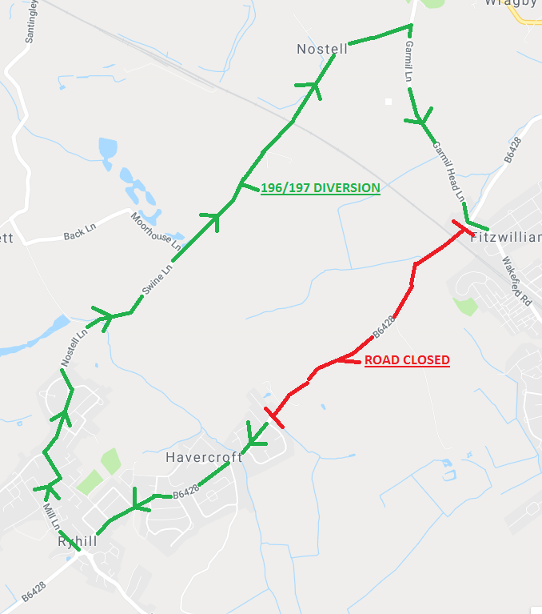 | Saturday 9th to Saturday 30th November | Arriva 196 197
School Lane  Walton | Christmas Lights Switch On  195 196 Divert via Greenside and Shay Lane | Sunday 1st December 1500-2000 | Arriva 195 196

ROADWORKS IN WAKEFIELD DISTRICT
Date of Issue: 21st November 2019
SECTION OF ROUTE | NATURE AND EFFECT OF WORK | DATES OF WORK | BUS OPERATOR
Doncaster Road junction with Slack Lane  Crofton | Emergency gas works  223 485 496 497 Delays to services due to three way lights at junction | Monday 4th November for approximately 3 weeks | BL Travel 223  CT Plus 485 Arriva 496 497

